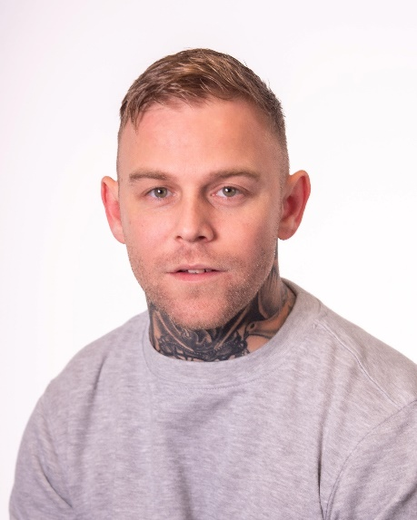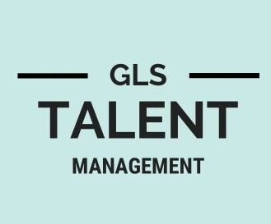3 Newlands Road

Southgate, Crawley

West Sussex, RH11 8AL 07780531881 gemma@glstalentmanagement.com www.glstalentmanagement.com

# Wayne Dobson

|  |  |  |  |
| --- | --- | --- | --- |
| Location  Height  Weight  Playing age  Ethnicity | **Middlesbrough**  **171 cm**  **71.67 kg**  **27/35**  **White** | Eye colour  Hair colour  Hair length | **Green**  **Light/Mid Brown**  **Short** |

## Film

2022, Callum (Lead), Wiccan, Lumar Films, Martin Handsley

2022, Tony, Night Girlz, Champ Dog Films, Jasmine Ebony Thomas

2022, Conrad, The Lynemouth Werewolf, Ben Eccles

## Television

2022, Prisoner, Happy Valley Season 3, Red Production Company, Fergus O'Brien

2022, Tony (one of the leads), Snatching Sanity, KC Entertainment Productions

## Short Film

2022, Steven (Lead), The Envelope, London University, Marianne Sill art

2022, Hennessy (Lead), Family Ties, Salford University, Gracie Nuttall

2022, Band Player, The Perfect Night, Stephane Alexandre

2022, Rob, Pilot, Giles Pengelly

2022, Bart, The Perfect Man, Dumb Blonde Productions, Alyse McCamish

2022, Joe (Lead), Not The Finest Hour, Manchester University, Dimitri Michael’s

|  |  |
| --- | --- |
| **Accents** | Cockney, Durham, Geordie, Middlesbrough, Sunderland, Teesside, |
| **Sports** | Air Rifle Shooting, Boxing, Jet Ski, Karting, Kick Boxing, Martial Arts, Motocross, Muay Thai, Quad Biking,  Thai Boxing, stage combat, weapons training |
| **Licences** | Car Driving Licence |
| **Other skills**  (* = highly skilled) | Angle Grinding, Bartender, Bricklayer (experienced), Construction (experienced), DBS (CRB) clearance, Handgun Handling |
| **Training** | Act up north tv and film acting |

The information in this CV may have been provided by partner sites. Every effort has been made to make sure that the information contained on this page is correct and Tagmin can accept no responsibility for its accuracy.

Wayne Dobson 1/1