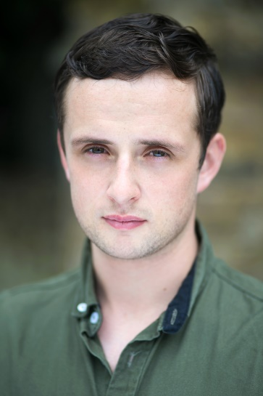 |  |  | Paraic Bermingham  Phone Number: 0044 7504251027  Email: paraicbermingham46@gmail.com  paraic-bermingham@hotmail.com  Spotlight: https://www.spotlight.com/3012-8946-9755  Showreel: https://youtu.be/AQIWbZT65Kc
Playing Age | 20-35 |  |  |  | Hair | Brown | Height |  | 5ft 9ins | Build | Average |  | Eyes | Hazel
Training
Film/Stage |  | Act Up Drama Classes, Tralee January-May 2017 (Tim Landers).
(Improvisation, voiceovers, breathing exercises, scene work, character building,
camera work )
 |  | Meisner Technique with The London Meisner Company (Robyn Paterson). 2019-2020
Method Acting with Louise O’ Leary from StandBy Method Acting School 2020-present
LEVEL 3, MODULE 2 THE WAR PROJECT, LEVEL 3, MODULE 3 ACTING FOR CAMERA, LEVEL 3, MODULE 4 MASTERING MONOLOGUES, LEVEL 4, MODULE 1 AUDITION TECHNIQUE
Theatre/Musical Theatre |  | Kerry School of Music, Scene work. 1998-2006
Firearm Training for Film and TV - |  | Handgun & Tactical Rifle Training for Film and TV (June 2021)  Advanced Firearm Skill Set Training for Film and TV (June 2021) Instructor - Benjamin Leonides
FILM & TV |  |  |  | PART |  |  |  | PRODUCTION |  |  |  | DIRECTOR
Breaking the Band: Judas Priest |  |  |  | Rob Halford |  |  |  | ITV Studios
Tools for Life |  |  |  | Mitch (Big Mouth) |  |  |  | Film Academy Baden-  Württemberg GmbH |  |  |  | Vincent Dolinsek
Dublin Narcos |  |  |  | Gang Member/ Criminal |  |  |  | Sky Documentaries |  |  |  | Benedict Sanderson
Complaints Welcome |  |  |  | White Criminal |  |  |  | Channel 4 |  |  |  | Jeanette Goulbourn & Tom Levinge
Fox In The Hen House |  |  |  | Mark/Marcus |  |  |  | 7375 Films |  |  |  | Jacob Hamilton
Dirty Diana |  |  |  | Robert |  |  |  | Christopher Ita Films |  |  |  | Christopher Ita
The Red Boot |  |  |  | Father |  |  |  | Filmcraft Productions |  |  |  | Malcolm Willis
Campfire (Post Productions |  |  |  | Pete |  |  |  | Film Academy Baden-  Württemberg GmbH |  |  |  | Vincent Dolinsek
Music Video |  |  |  | PART |  |  |  | COMPANY |  |  |  | DIRECTOR
Sam Fender – That Sound |  |  |  | Young Male |  |  |  | London Alley Productions |  |  |  | Tim Mattia
Barry Moore - The Tide |  |  |  | Window Cleaner |  |  |  | Friend Productions |  |  |  | Aube Perrie
YUNGBLUD - God Save Me, But Dont Drown Me Out |  |  |  | Thug 1 |  |  |  | Mr. Anderson Limited / Feud Creative |  |  |  | Yungblud and Gavin Gottlich
Ak4ti7 featuring EA |  |  |  | Detective |  |  |  | GRM Daily |  |  |  | Nelson Ilori
PLAY |  |  |  | PART |  |  |  | THEATRE |  |  |  | DIRECTOR
The Somnambulist |  |  |  | Tyler |  |  |  | Drayton Arms Theatre |  |  |  | Alicia Brockenbrow
Shot to Fame, Fake News, Alternative Fact |  |  |  | Prince Harry Impersonator/Donald Trump Supporter |  |  |  | Soho Theatre |  |  |  | Alison Jackson
Skills
- Improvisation
- Voice Over
- Radio Presenting
- Kickboxing
- Full Driving License
- Camera Work with DSLRs
- Editing Experience with various editing software.
- Scriptwriting
- Tactical Rifle and Pistol Training for Film and TV
- Advanced Firearm Skill Set Training for Film and TV

Accents
All regional Irish accents, regional English, English RP, Welsh, Standard/ Southern American accent, New York Accent.

