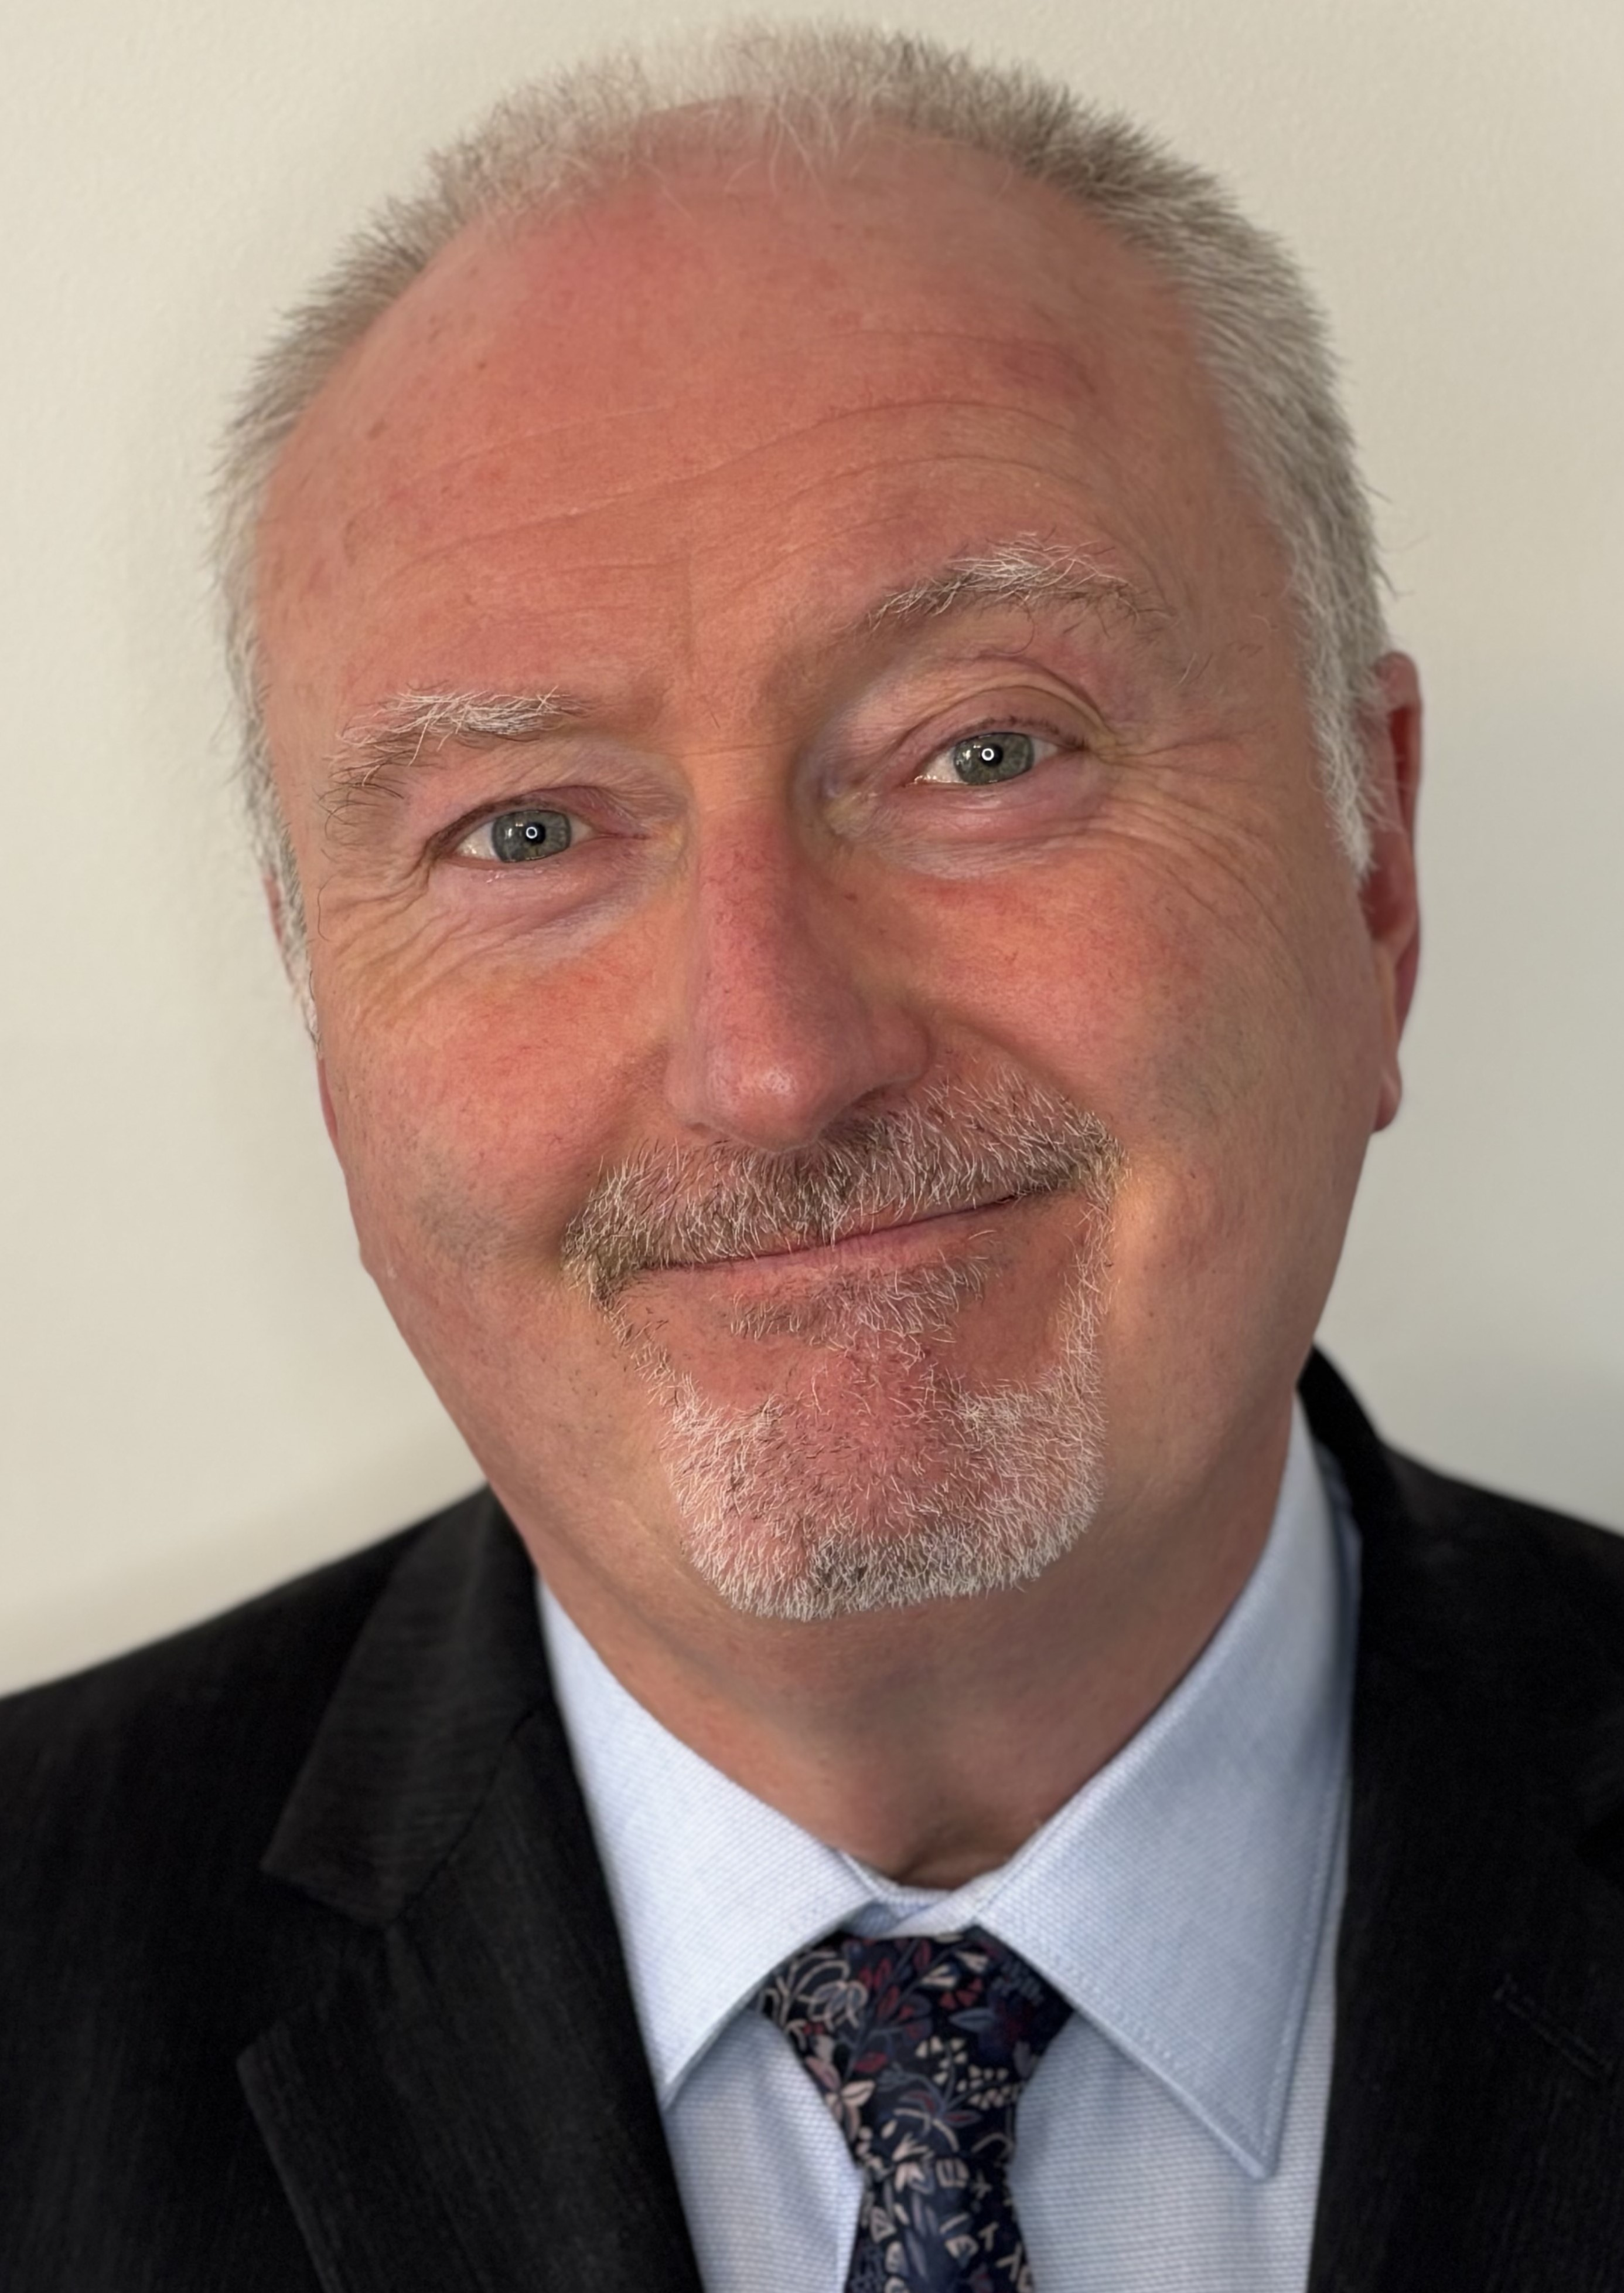
Mobile: 0777 348 4014
Email: bernarddelaney@hotmail.co.uk
Spotlight: https://app.spotlight.com/1898-0169-9645
Location: Manchester
Height: 1.78m
Hair: Grey
Eyes: Grey/Hazel
Accents: RP, Mancunian, Liverpudlian, Geordie, general Scottish
Role playing age: 56 – mid 60’s

Personal Profile/Personal Attributes
- Strong organisation skills and drive.
- Leading workshops in Drama
- Physical theatre skills
- Devising and improvisation
- Excellent interpersonal skills – Well presented, good communicator, high integrity, works well with others. Extremely reliable and dependable.
- Actor DBA checked – qualified secondary school Drama Teacher
- Clean driving licence

Experience
Film – As Actor
Ruff & Ready – Directed by Luke Walters, Bern Lafferty. 48 Hr Film Festival. 2025

The Dotted Line – Directed by Phil Hawkins, Police Officer Collins. BBC funded project. 2006
TV – As Actor
Hollyoaks – Lime Picture Production, SA. 2025
Run Away – Quay Street Productions. Executive Producer: Harlan Coben. Professor character SA, 2025.
Theatre – As Director
Monster – Written by John Doona. Dukes ’92 Upper Theatre Venue, Castlefield. Manchester 2000
Theatre – as Actor
The Crime of the 21st Century – Written by Edward Bond (celebrated playwright), Directed by John Doona. Lead character of Grig. Dancehouse Theatre, Manchester 2002. This play was supported by the playwright who spoke to an invited audience post production.
Ragged – Directed by Grant Fairlie, written by John Doona. Main Character ‘Gunn’. Dancehouse Theatre, Manchester. August 1998
Linger – Written and Directed by John Doona. Lead character ‘Pep’. North Manchester Peoples Theatre (School site) 1997
Radio – As Voice Actor/impersonator
The Glorious Get-together – Written and Directed by Alfie Joey for Radio 4, the voice of Sean Connery as James Bond 1. Broadcast 2004.

Education
- BA (Hons) – Theatre and Media Studies Degree. Bolton and Manchester University 1995.
- PGCE – Drama – Manchester Metropolitan University, Didsbury, Manchester. 1996.

