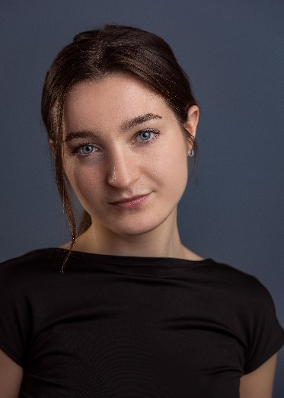
Paisley Hillier
Gender: Female
Contact details Age: 19
Email: phillier2005@gmail.com Playing Age: 14-23 yrs
Mobile: 07947 362077 Height: 5’4 (162cm)
Eye colour: Blue
Representation Hair colour: Brown
Terra Libra Agency Hair length: Medium/Long
Email: hello@terralibra.co.uk Ethnicity: White
Phone: +44 7753 743 739 Nationalities: British/Polish
Base(s): Oxfordshire/London

Spotlight: https://app.spotlight.com/4930-9059-9486
IMDB: https://www.imdb.com/name/nm16016454/?ref_=nv_sr_srsg_0_tt_2_nm_1_in_0_q_paisley%2520hillier
Mandy account: https://www.mandy.com/u/paisley-hillier/

Film/TV/Commercial
Year Project Role Director/Production
2026 Kill Karina Kill Chloe Jones BlackCoppiceFilms Chris Shane Sanders
2026 Cult Night Ember Mahoney Raya Films London James Smith
2026 Amelia Drama student Macroversefilms Luke Mepham
2025 Therapy Claire Marks 8PunchFilms Scott Clist
2025 Daggers Inn Waitress Raya Films London James Smith
2024 Dead By Midnight Dead girl/Zombie Fran Mineo
2024 Social Media Skits Various SmilingMonkeyProductions
2024 Customer Service Training Video Upset Customer Activate Learning
2023 Release Me Skylar Emilee Noble

Stage
Year Project Role Production/Location
2024 Chicago the Musical Velma Kelly Oxford City Stage & Screen
2023 The 39 Steps Anabella Schmidt/ Witney Dramatic Society Albright/Ensemble
2023 The Monkey’s Paw Jo Witney Dramatic Society
2023 In Our Silence There Is Noise Kate Oxford City Stage & Screen Devised Theatre
2023 Dancing through the Decades Dance ensemble Oxford City Stage & Screen
2023 Scott’s Showcase Dance ensemble Scott’s Showcases New Theatre Oxford
2023 Join the Circus Dance Captain/ Oxford City Stage & Screen Rose from ‘Gypsy’
2023 Disney’s Marvel Dance ensemble Disneyland Paris Superheroes and Villains
2022 Back to the 80’s (musical) Ensemble/Understudy Buttercross Theatre (Director – Debbie Tuffs) – (Mel/Kim)
2019 Puss In Boots (pantomime) Kids Ensemble Chipping Norton (Director - John Terry) Theatre
2019 Macbeth Lady Macbeth Bard ‘@’ the Box
2018 Dick Whittington and His Cat Kids Ensemble Oxford playhouse (Director - Steve Marmion)
2017 The Nutcracker & the Mouse King Stretch/Kids Ensemble Cornerstone Theatre (Director – Andrew Barry)

Education/Training and Qualifications | Skills
- UAL Level 3 Extended Diploma in Performing and Production Arts  - 1 day Stunt Basics with Movieworks  - 1 day Katana combat Stunt basics with Movieworks  - West Oxfordshire Academy of Performing Arts (WOAPA) (5 Years)  - West End Stage Summer School (Grade: Distinction)  - L1 Dance Leadership qualification (Body Politics Oxford) | Accents: Standard English (Native), General American, Southern American, Scottish, French, German, RP British  Dance: General, Street Dance, Musical Theatre, Dance Captain, Choreography  Singing: General, Musical Theatre, Mezzo-Soprano  Sport: TaeKwon-Do (11 Years), Kickboxing (5 Years)  Other: Stunt/Stage combat (beginner), Drumming  License: Driving Licence (Manual Car)

