Trevor Atkinson
Email: Trevor.atkinson@gmail.com | Phone: 07730 871116
Representation: Self-represented for acting roles. Also registered for stand-in, double, featured and background work with Rachel’s People, Onset Extras, Entertainment Partners, The Casting Collective and UVE.

CASTING PROFILE
Playing age: 45 -55| Height: 6ft | Eyes: Blue | Build: Medium | Weight: 11st 12lb / 76kg | Shoe size: 11
Hair/head: Bald/clean-shaven head or short brown/greying hair
Facial hair: Clean-shaven or short brown/greying stubble

PROFILE
Experienced Stand In, Double and Actor with Film, TV, commercial, corporate and live production credits. Currently training with The Actor’s Lounge, Cambridge, a Spotlight-accredited programme, with 4 out of 6 semesters complete. Flexible on availability and travel, including multi-day projects supported by camper van accommodation, and able to provide a choice of costumes.

KEY SKILLS & AVAILABILITY
- Screen experience: Stand-In, Double, featured artist, Deep Background roles across TV, film, commercials, and corporate productions
- Action skills: Sword, spear, and shield training; fencing experience in Épée; advanced assault rifle, shotgun, and Handgun firearm training to advanced level
- Character types: Professional, authority, teacher, security, military, historical, imposing/heavy and everyday public roles. Character driven with experience in drama and comedy
- Availability: Flexible for short-notice bookings, travel, and multi-day/week projects, with camper van accommodation available for location work
- Wardrobe: Able to provide a choice of costumes for production needs

TRAINING & MEMBERSHIPS
- The Actor’s Lounge, Cambridge — Spotlight-accredited training, 4 out of 6 semesters complete
- Online acting and screen performance courses
- National Firearm Association(NFA) Member
- Equity Member
DBS: Certificate available on request — valid from 25-Oct-2025

Productions – covering Scripted roles, Background extra, Featured Roles, Doubling, Stand - in

Film
- Peter Venkman — principal cast double for Bill Murray — Ghostbusters: Frozen Empire
- Heavy / Snooker Club Player — Wife & Dog
- Dada – Cricket Umpire – Leeds
- Project 79 — Passerby / Business Executive — Birmingham

TV & Commercial
- Stand in – for Timothy Olyphant -Mr October
- Stockbroker – Industry 5 (recurring office staff) – Cardiff
- Stand-In for Ralph Davis — Slip 3 - Apple TV — Reading & London
- Devil in my DM’s - murder victims' partner/ SOCO/ plain clothed Police detective/ forensic scientist / computer scientist – Hulu/ Disney+ London
- Silent witness S30-Senior police officer – Birmingham
- Lightbulb — Doctor — Apple TV — Middlesex
- Jack Wright, Series 2 — Featured Role: Prison Guard — BBC — Reading
- Football Supporter — BetVictor Commercial — Sheffield
- EastEnders — Guard — BBC — Aylesbury
- Black Doves, Series 2 — Mercenary / Dead Body — Netflix
- Nando / Ted Lasso s4— Supporter & Featured Ticket Sales — Apple TV — London
- Onwards & Sideways — Racecourse Punter & Restaurant Client — Norfolk
- TCD / The Chelsea Detective — SOCO — Cambridge
- The Face of Evil — Biker — Arrow Media
- Mechanical/Silo s4 — Miner — Apple TV — Aug, Sept, Oct, Nov, Dec & Jan ’26
- Silent witness s29 — Security Walk-On — BBC Drama
- Larkin / Down Cemetery Way — Office Manager — Apple TV
- Gandhi Biopic — 19th Century Bystander, Mob Member & Boer War British Soldier — Applause Entertainment
- Red Gun 2/House of Dragons — Soldier — HBO
- Greater Anglia Railways Commercial — Tourist

Corporate
- Linney Marketing — Printing Team Lead — scripted internal staff training role
- ServiceNow Commercial — Field Service Technician — Birmingham

Live Events & Productions
- Boudica, Mask Theatre — King Kundervik / Belgic Warrior / Druid
- What I Did at School Today — Principal Cast: Dan — comedy amateur dramatics production
- Dirty Dustin — Principal Cast: Dave — comedy amateur dramatics production
- Hot Milk Music Album Launch — Heavy / Imposing MIB role interacting with attendees

PHOTO PAGE
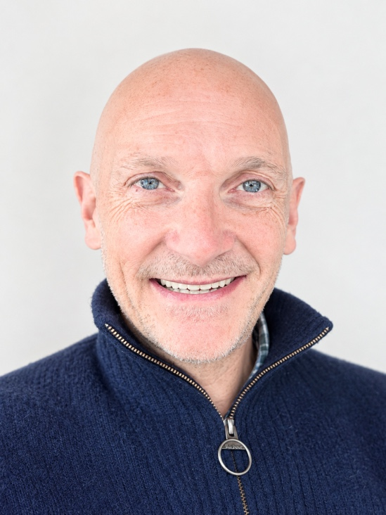
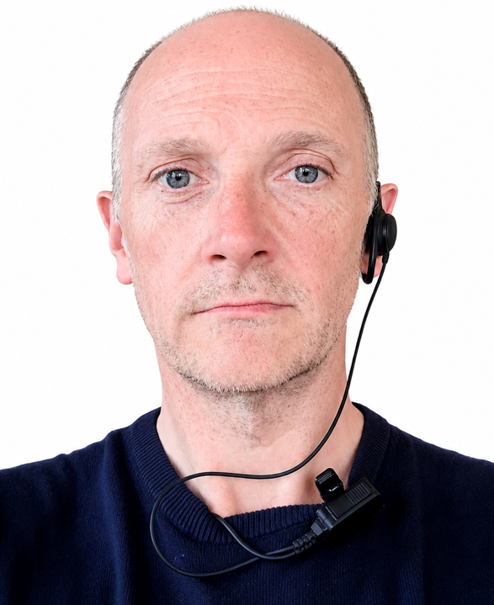
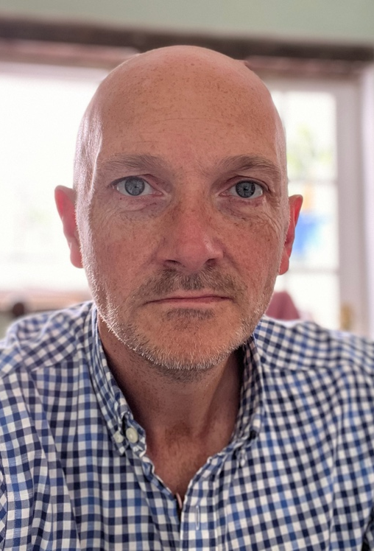
Trevor Atkinson
Casting Profile Photo Shots
